Rider-Waite card | 8 Pentacles in the Old Aeon  8 Pentacles Old Aeon says about pleasure of the job, from what he does and what he gets. Moreover, at first glance, in this card, there is no negativity. Yes, there is no negativity in the understanding of the Old Aeon. Because the Old Eon is not focused on change and development. Old-Eight 8 pentacles - extremely conservative card involves working from a template, for the last time-established models.  In addition, this problem becomes obvious only if we come to an understanding of the eight pentacles through the principles of the New Aeon.
Mtoe card | 8 Pentacles in the New Aeon  The card emphasizes that the key to mastery in the New Eon lies through constant development, through improvement, through the development of new techniques and principles in the work.

Card from Waite | 9 Pentacles in the Old Aeon  9 Pentacles of the Old Aeon speak of profit and wealth. Waite card character emphatically aristocratic. And in the depth of the card lies the superiority of one person over another, conditioned not by personal qualities, not by talents, not by skills, but only by a happy opportunity to be born into a rich family.  9 Pentacles Old Aeon conceals within itself the abyss into which the man feels his supposed superiority over others, risks to fail completely.
Mtoe card | 9 Pentacles in the New Aeon  9 Pentacles of the New Aeon shows that it is not at all necessary to have wealth and feel yourself as a kind of superhuman. Moreover, one of the hidden meanings of this card is connected with the thesis that man should not live in poverty and misery. In addition, that it is not necessary to be a swindler and a con man to provide yourself. The lesson is complex and not all are capable of accepting it, applying it to oneself and enjoying its fruits.

Rider-Waite card | 10 Pentacles in the Old Aeon  0 pentacles speaks of a clan, family, family, about happiness expressed through these concepts. From the viewpoint of Old Aeon, clan and genus are rigid hierarchical structure, which is in patriarch management. The happiness of the 10 pentacles is due, first of all, to the denial of their rights and the increase in their duties.
Mtoe card | 10 Pentacles in the New Aeon  In the New Eon, 10 pentacles, in addition to the traditional family and gender, also represent a network structure not based on hierarchical principles. It is, rather, a swarm than race. Happiness of each is not connected with the renunciation of self-interest in favor of the kind of interest. Card`s lesson is that in the New Aeon family organized on different principles. There is no need to break a person in order to ensure the interests of the family. There is an opportunity to find a balance between "I" and "We".

History of the Magic Tarot of the New Aeon

For the first time, I met the deck when I started practicing the Tarot. In 1993, there were no normal decks in Russia. My friend lived in Prague. I wrote to him "Tolik, I started to study the Tarot, I look for a normal deck, and maybe you can accidentally find some good one".

He said that many friends wrote to him various requests, but he decided to fulfill my request by an old friendship. He had to go around a few books and antique shops to find a deck. To get to the store, you had to climb the iron stairs to the second floor. There was not even a signboard. He said that he had been led there.

He bought the deck and sent it to his parents.

When the parcel came, his father came and handed me a deck. Together with it, there were two books on Tarot, but they had no relationship to the deck. The deck itself did not even have a box. The cards were divided into 3 blocks of 7-8 cards and sealed in cellophane. And nothing more.
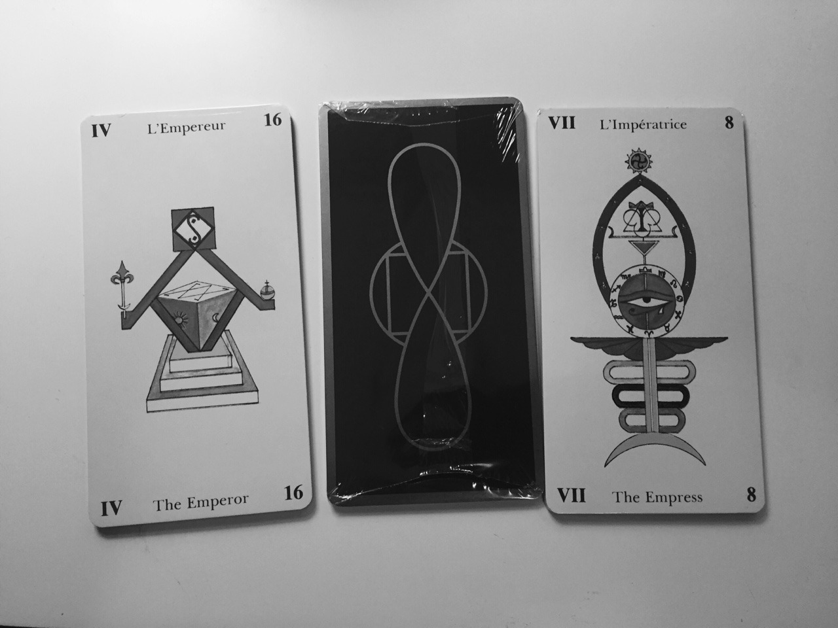

I tried to find out from him what kind of deck it was. "I do not know, you asked Taro, I bought you." I looked at this deck and did not understand what it was like, how to work with it, where to put it. Moreover, it was in German.

For several months, it lay with me. With grief in half, I translated the names of the cards. I had a long time understanding what the numbering was. It did not coincide with the canons. I began to meditate on maps to better understand them, to be immersed.

At some point, I understand that this is a magic deck. That it connected with magic. In the course of lunch, it comes to me that it needs to be applied to magical questions. In addition, the same evening a client comes to me with a magical question. I give him a shuffle card, as usual. He takes a deck and says that it is hot. I can`t hold it in my hands. However, for me the deck was the most usual, I did not feel anything.

But surprising was that the cards were read as from a sheet. It is simple. Everything that previously I could not understand, foldout cards and just saw.

A few months later, I went to the Czech Republic. There I bought an encyclopedia Tarot and the first thing I did was to look for this deck. I open the encyclopedia; I read the title "Magic Tarot". Written by Frederick Lionel. I did not even know the name of the deck and from where it came from. However, I hit the mark.

Then I started to work with this deck. The more I was working, the more I started to see. The more I began to feel the card`s scenario in the hands.

Since then, I have tried more than 80 decks, but so I did not meet the deck better.

I say that, on the one hand, it is not a deck that is trying to guess, the tarolog is guessing. That is how Paganini played on one string, but still sounds great. On the other hand, there is a difference. When you have a good tool, and when you have a tool that is falling apart in your hands. When it's terrible to take it in your hands.

With conventional decks, you have to make efforts to extract subtleties, but here you can open your eyes and see everything.

Unfortunately, this deck had one feature that always upset me .... There are only 22 cards in the deck. It consists exclusively of the Elder Arcana.

The absence of the Minor Arcana is a huge loss for the deck. But think about this, despite this shortcoming, I chose it as my main working tool.

I had a dream that one day; this deck will have the Little Arcana. Nevertheless, in 1999 I realized that this would never happen. Lionel Frederick died, and with it my hopes to see a continuation of the deck.

After some time, I have an idea - to create the Little Arcana myself. But I quickly realized that at that moment, I could not give the Little Arkans the same depth and volume as Lionel's.

I postponed this idea, but did not forget about it...

Once I dreamed of the widow of Frederick Lionel. I shared with her the idea that I want to finish the deck, and she accepted it enthusiastically. She said: "You know, Frederic will be so happy about it."

In 2016, I contacted artist Yevgeny Vinitsky and agreed to work together on the Minor Arcana. We have already worked with Eugene on the Russian Taro Lubok deck.

Mage | Knight of Swords | 6 Cups

If you see this deck or other decks of Eugene, you already understand how beautiful he draws and conveys deep knowledge about the cards.

Work on the deck lasted 2 years.

When we with Eugene Winitzki finished work on an image of cards, I had printed proof. The probe proved to be excellent. As soon as I got this deck in hand, I assumed that I would not need any more decks. Now I have already worked with the deck, and even put Waite aside.

For me, the first print edition of the deck - a historic moment. I invite you to share this moment with me. If you are interested in becoming part of this event, then now I will tell you how to do it...

Do you want to become one of the first holders of the deck?

The authors of the deck

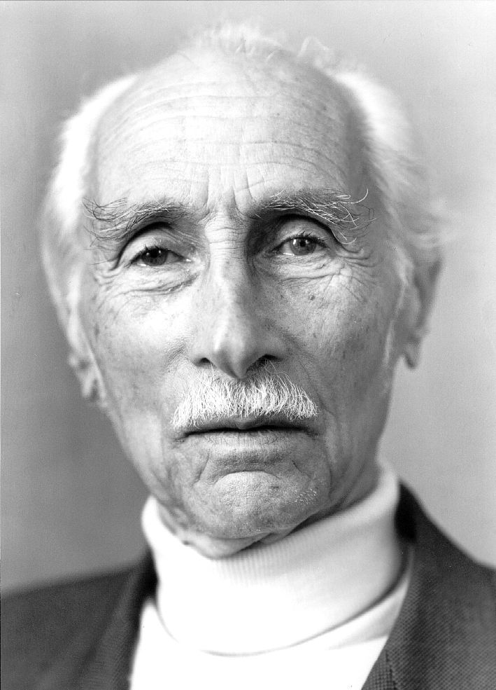 | Frederick Lionel, creator of the original maps of the Elder Arcana  ● French engineer, Resistance member, writer, philosopher and spiritual master.  ● He became an officer of the British secret service and returned to occupied Europe to help move the Nazi-persecuted people from the occupied territories. About 1,300 people were saved. These events he described in his book "Challenge" ("The Challenge") (1976).  ● When he was 55 years old, he sold the business and began his spiritual journey.  ● Christ. F. Lionel wrote about 30 spiritual books and essays on spirituality, mysticism, catarrh, alchemy, astrology and tarot and became an esteemed spiritual master in many countries.  ● Frederick Lionel peacefully died on December 22, 1999 in Paris.

photo | Sergey Savchenko, creator of the Magic Tarot of the New Aeon  ● Master of Tarot and Magic, the founder of the Russian Tarot School  ● Head the Department of Integrative Psychology and Prediction at the European Institute for Interdisciplinary Research and Education  ● Sergei Savchenko is engaged in Magic and Tarot cards for 24 years. Over the course of his practical work, he has trained more than 5,000 people around the world - in Russia, Ukraine, the Czech Republic, Slovakia, the USA, Canada and other countries.  ● The author of the books "Evening tea by candlelight and Tarot cards", "Tarot and Business", "Tarot and Relations", "Symbolic Socionics: a non-healing for the philosopher", a series of textbooks "Taro Kshatriyev", author of 54 courses in Tarot and Magic

Photo of Eugenia, which he sent | Eugene Vinnytsky, artist of the Magic Tarot of the New Eon  ● Born in Moscow on June 17, 1957 in the family of the artist David Vinitsky.  ● Graduated from the Art Faculty, Institute of Cinematography (VGIK).  ● Worked as a stage designer at the Mosfilm studio.  Since 1990 lives and works in Geneva, Switzerland.  ● His works are in private collections in Friborg, Geneva, Frankfurt am Main, Dusseldorf, Lyon, Washington (Klutznik Museum), Phoenix (USA) personal exhibition at the UN (Geneva) 1993.

Other Tarot Decks, painted by Eugene Vinitsky:

Mocap cards of the Sun,  The deck can look out from it,  with other mocaps as well  Russian Lubok Tarot | 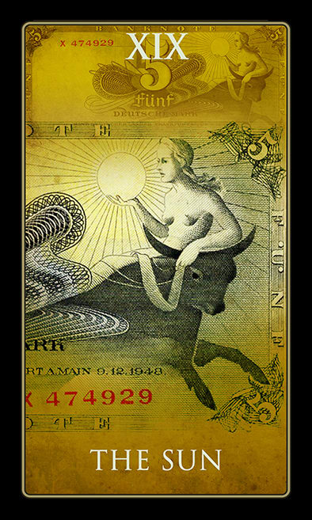  Money Tarot
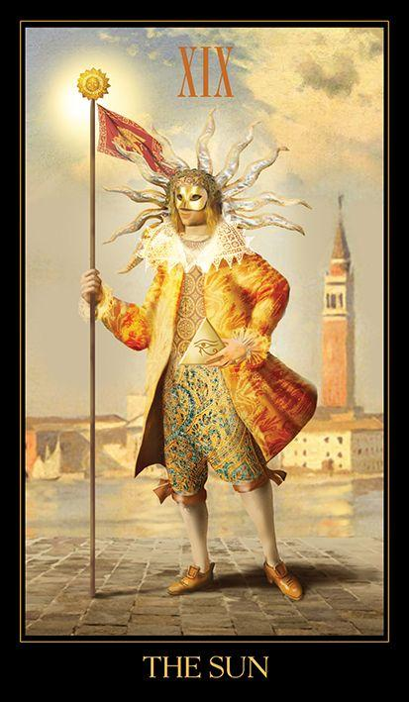  Venetian Tarot | 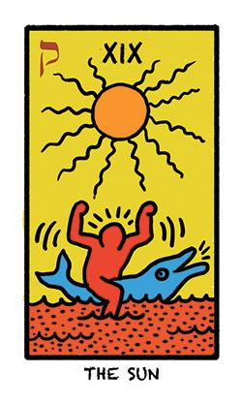  The World in Colours Tarot

Letter 1

Thank you for being interested in the Magic Tarot of the New Aeon.
We with the Russian Tarot School invested a lot of effort so this deck could see the world.
Therefore, in honor of the launch there is a big discount, it will work for you for the next 2 days.
To understand what kind of deck, download the promised Guidebook.

Yet, subscribe to the news of the Magic Tarot of the New Aeon on Facebook
(link)

Letter 2

Your discount coupon →
Your discount coupon still works...

Letter 3 - in 6 hours

Save 30% or discount will burn in 3 hours →
Your discount coupon still works...

